LAB 9(A)
Tinker Cad Link: https://www.tinkercad.com/things/g11G5lnciVm-lab-9-a/editel?sharecode=xuMnSo_YZn4I-sHlBQIB0v48Z-0oSUf1-TVNdV7RgvM
Circuit Diagram:
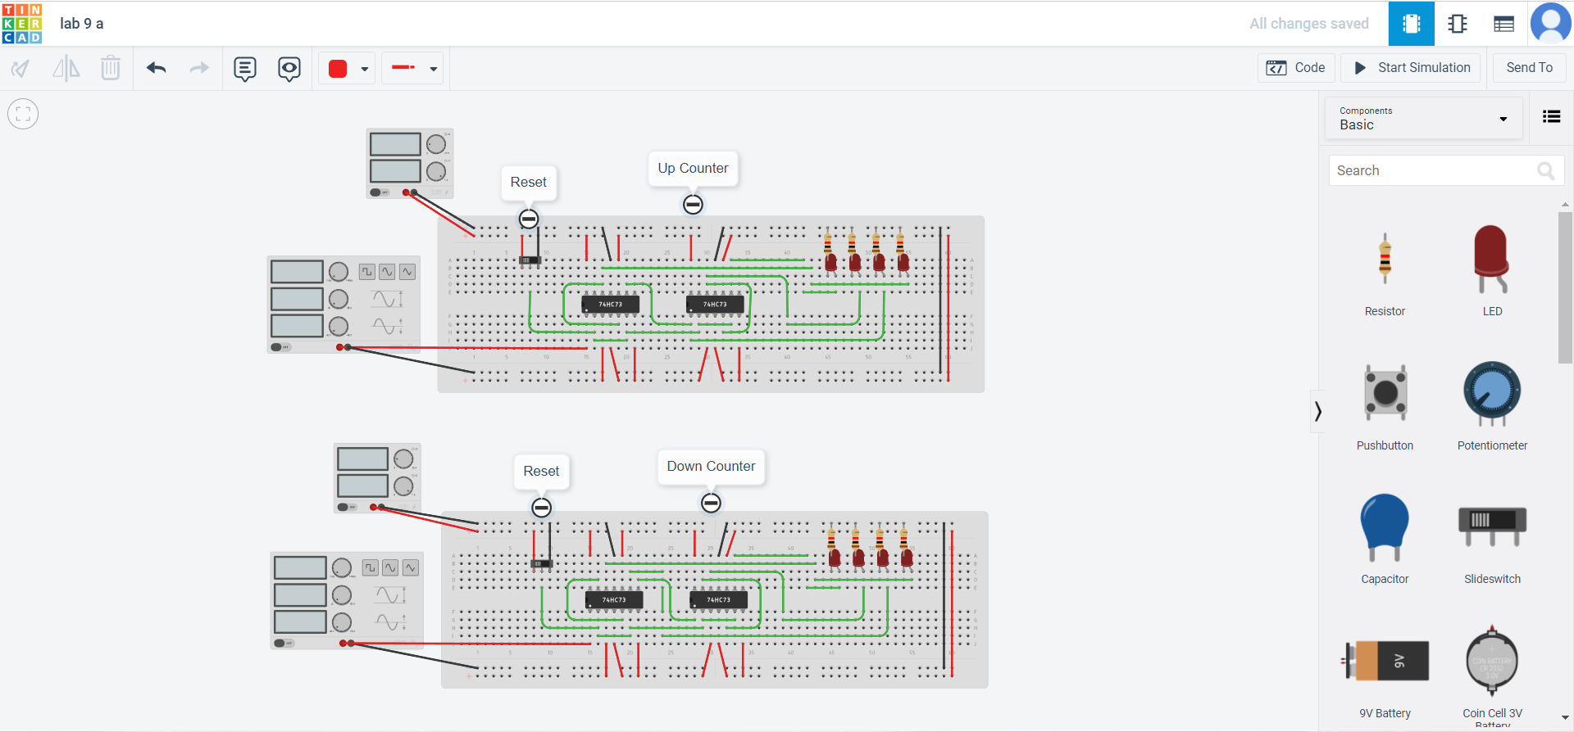

Pin Diagram:
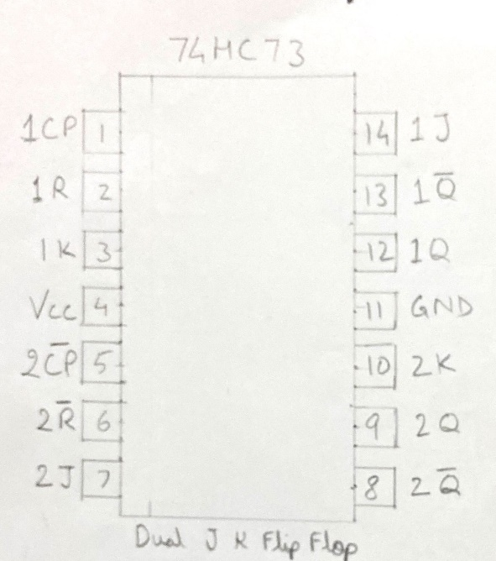

Truth Table:
clk cycle | Q3 | Q2 | Q1 | Q0
0 | 0 | 0 | 0 | 0
1 | 0 | 0 | 0 | 1
2 | 0 | 0 | 1 | 0
3 | 0 | 0 | 1 | 1
4 | 0 | 1 | 0 | 0
5 | 0 | 1 | 0 | 1
6 | 0 | 1 | 1 | 0
7 | 0 | 1 | 1 | 1
8 | 1 | 0 | 0 | 0
9 | 1 | 0 | 0 | 1
10 | 1 | 0 | 1 | 0
11 | 1 | 0 | 1 | 1
12 | 1 | 1 | 0 | 0
13 | 1 | 1 | 0 | 1
14 | 1 | 1 | 1 | 0
15 | 1 | 1 | 1 | 1

KMaps:
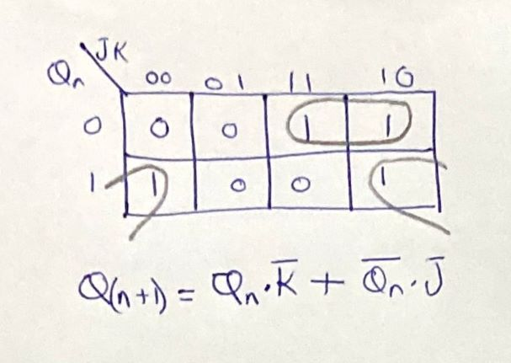

Characteristic Equation:
Q(n+1)=Q(n).K’ + Q(n)’.J
J=K=1
Q(n+1)=Q(n)’

Observation:
For the up counter the Q of each J K Flip Flop is connected to the clock of the next Flip Flop.It counts up from o to 15 and then again starts from 0.
Up Counter:
clk cycle | Q3 | Q2 | Q1 | Q0 | Decimal
0 | 0 | 0 | 0 | 0 | 0
1 | 0 | 0 | 0 | 1 | 1
2 | 0 | 0 | 1 | 0 | 2
3 | 0 | 0 | 1 | 1 | 3
4 | 0 | 1 | 0 | 0 | 4
5 | 0 | 1 | 0 | 1 | 5
6 | 0 | 1 | 1 | 0 | 6
7 | 0 | 1 | 1 | 1 | 7
8 | 1 | 0 | 0 | 0 | 8
9 | 1 | 0 | 0 | 1 | 9
10 | 1 | 0 | 1 | 0 | 10
11 | 1 | 0 | 1 | 1 | 11
12 | 1 | 1 | 0 | 0 | 12
13 | 1 | 1 | 0 | 1 | 13
14 | 1 | 1 | 1 | 0 | 14
15 | 1 | 1 | 1 | 1 | 15

Down Counter:
clk cycle | Q3 | Q2 | Q1 | Q0 | Decimal
0 | 1 | 1 | 1 | 1 | 15
1 | 1 | 1 | 1 | 0 | 14
2 | 1 | 1 | 0 | 1 | 13
3 | 1 | 1 | 0 | 0 | 12
4 | 1 | 0 | 1 | 1 | 11
5 | 1 | 0 | 1 | 0 | 10
6 | 1 | 0 | 0 | 1 | 9
7 | 1 | 0 | 0 | 0 | 8
8 | 0 | 1 | 1 | 1 | 7
9 | 0 | 1 | 1 | 0 | 6
10 | 0 | 1 | 0 | 1 | 5
11 | 0 | 1 | 0 | 0 | 4
12 | 0 | 0 | 1 | 1 | 3
13 | 0 | 0 | 1 | 0 | 2
14 | 0 | 0 | 0 | 1 | 1
15 | 0 | 0 | 0 | 0 | 0

For the down counter the Q’ of each J K Flip Flop is connected to the clock of the next Flip Flop.It counts down from 15 to 0 and then again starts from 0.
Applications:
Used in microwaves to heat the food for a set amount of time.
It is used in washing machines and stops the machine after a set time.
It is used in digital clocks to show time and in analog to digital converters.

LAB 9(B)
Tinker Cad Link: https://www.tinkercad.com/things/f5GAZa6uRUi-lab-9-b/editel?sharecode=j-qQ9zJuo2VZcqRzWvjbq9gcfjgtJ1KoWlsN9KJwep8
Circuit Diagram:
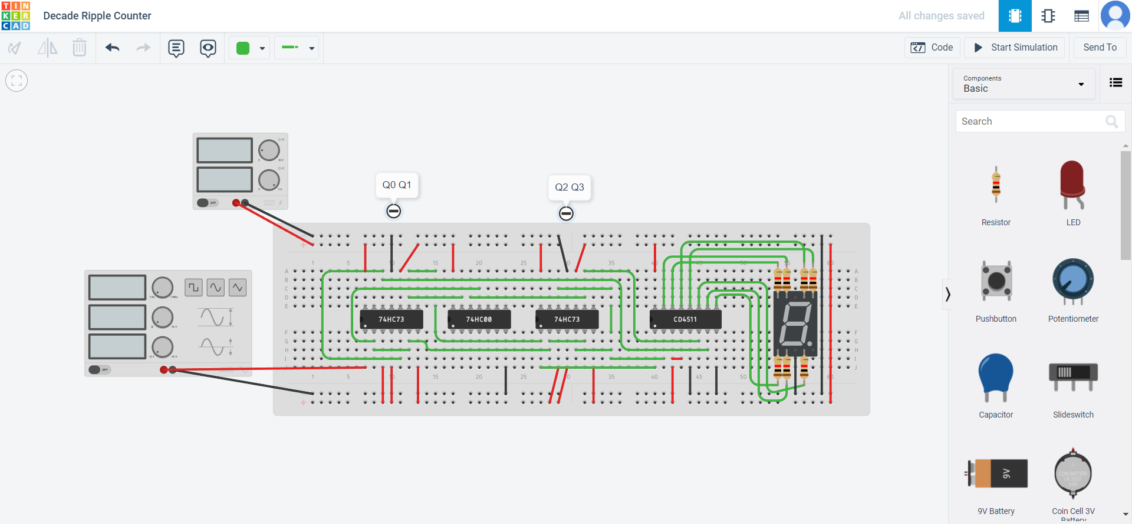
Pin Diagram:
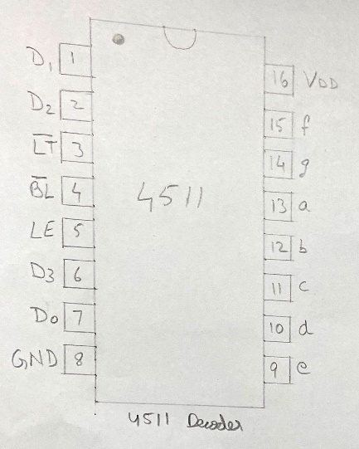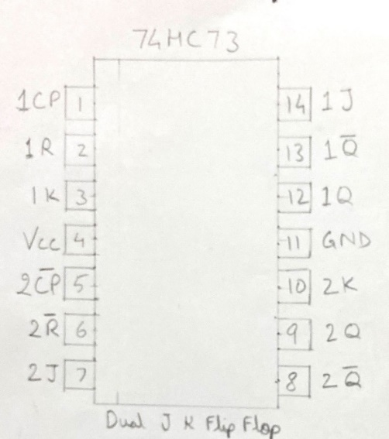

Truth Table:
clk cycle | Q3 | Q2 | Q1 | Q0
0 | 0 | 0 | 0 | 0
1 | 0 | 0 | 0 | 1
2 | 0 | 0 | 1 | 0
3 | 0 | 0 | 1 | 1
4 | 0 | 1 | 0 | 0
5 | 0 | 1 | 0 | 1
6 | 0 | 1 | 1 | 0
7 | 0 | 1 | 1 | 1
8 | 1 | 0 | 0 | 0
9 | 1 | 0 | 0 | 1

Kmaps:


Characteristic Equation:
Q(n+1)=Q(n).K’ + Q(n)’.J
J=K=1
Q(n+1)=Q(n)’

Observation and Justification:
clk cycle | Q3 | Q2 | Q1 | Q0 | Decimal
0 | 0 | 0 | 0 | 0 | 0
1 | 0 | 0 | 0 | 1 | 1
2 | 0 | 0 | 1 | 0 | 2
3 | 0 | 0 | 1 | 1 | 3
4 | 0 | 1 | 0 | 0 | 4
5 | 0 | 1 | 0 | 1 | 5
6 | 0 | 1 | 1 | 0 | 6
7 | 0 | 1 | 1 | 1 | 7
8 | 1 | 0 | 0 | 0 | 8
9 | 1 | 0 | 0 | 1 | 9

The ripple counter counts from 0 to 9 and then gets reset to 0.The reset pin function is:
Reset=(Q3.Q1)’
The reset will be low when Q3 and Q1 are high that is when counter reaches to 10 (1010 in binary).The reset is active low reset

Applications:
Used as frequency counters.It can be used to calculate the frequency of an unknown source/counter.
Used to design sequencers and clock circuits and state machines.It is used in clock generation.

